LearnMate (AI StudyBuddy) - Project Testing Phase

API Route Interface Endpoints
The backend exposes RESTful APIs to interact with the database and AI services.

1. Authentication APIs
Handles user registration, login, JWT authentication, and protected route access.

2. Study Material APIs
Allows users to upload, retrieve, update, and manage study materials.

3. AI Feature APIs
Provides endpoints for:
- AI Summary Generation
- AI Flashcard Generation
- AI Quiz Generation
- AI Study Plan Generation

4. Administrative APIs
Provides administrator-only endpoints for managing users and monitoring system activities.

Epic 5: Project Execution
The AI StudyBuddy backend can be executed locally using Node.js. Before running the application, ensure that MongoDB is running and the required environment variables are configured correctly. The backend exposes REST APIs that can be tested using Postman or Thunder Client.

Running the Backend Server
Install all required dependencies:
npm install
Start the development server:
npm start
After successful execution, the server connects to MongoDB and starts listening for incoming API requests.

API Testing
The backend APIs can be tested using Postman.

1. User Registration
Registers a new user by accepting the required details and securely storing the encrypted password in the MongoDB database.
Endpoint:
POST /api/auth/register
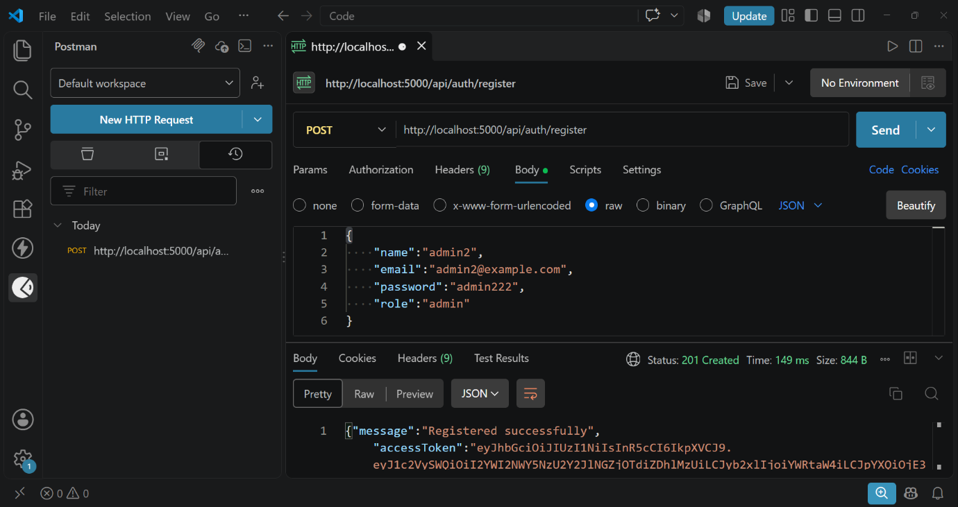

2. User Login
Authenticates the registered user and generates a JWT access token for accessing protected APIs.
Endpoint:
POST /api/auth/login
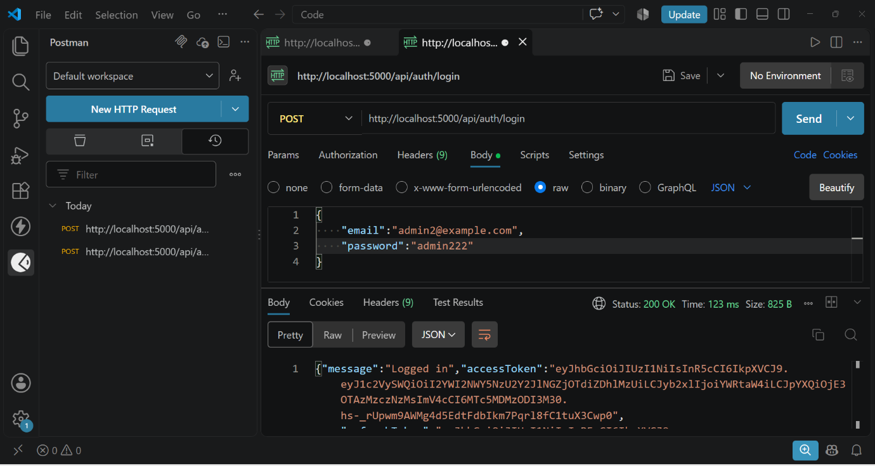

3. Upload Study Material
Allows authenticated users to upload study material that will be used as input for AI-powered content generation.
Endpoint:
POST /api/material/upload
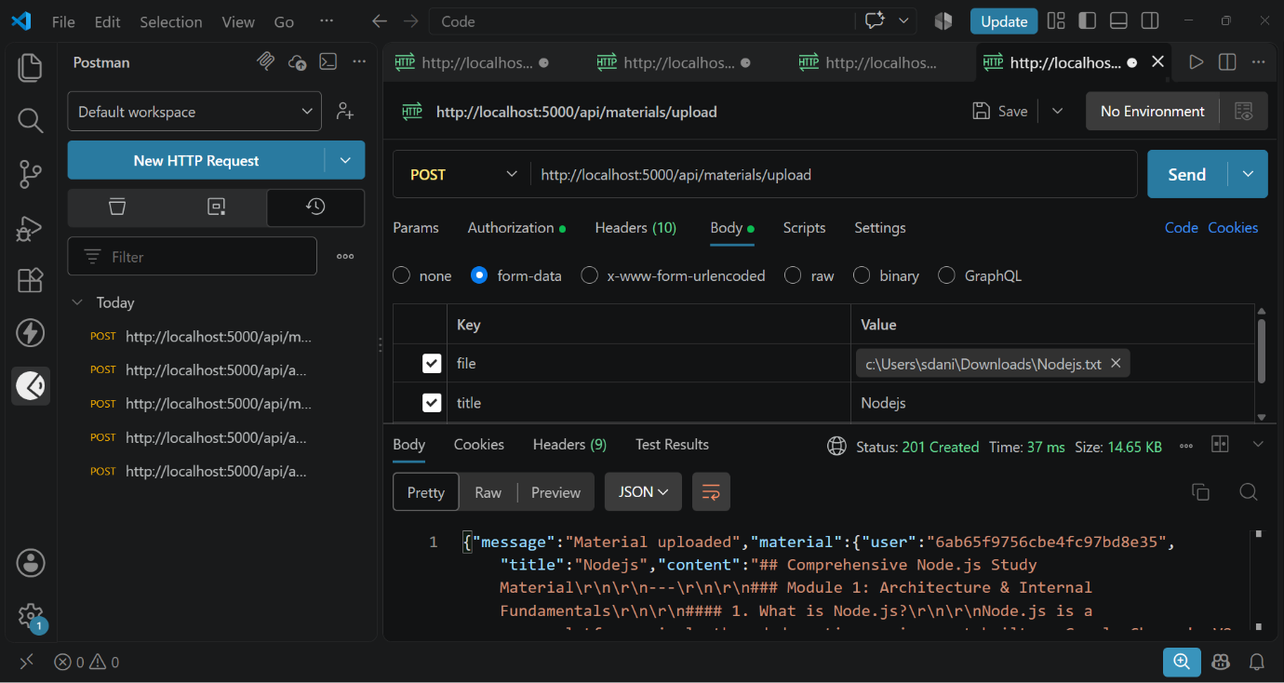

4. Generate AI Summary
Sends the uploaded study material to the Google Gemini API and generates a concise summary.
Endpoint:
POST /api/materials/:id/summarize
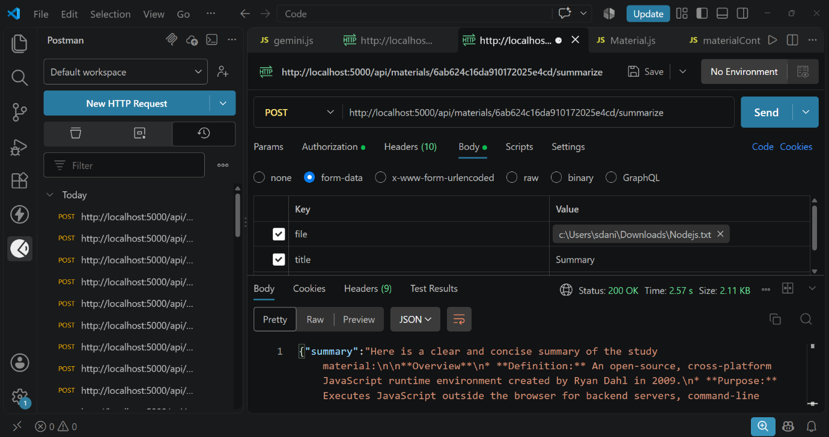

5. Generate AI Flashcards
Creates AI-generated flashcards from the uploaded study material for effective revision.
Endpoint:
POST /api/ai/flashcards
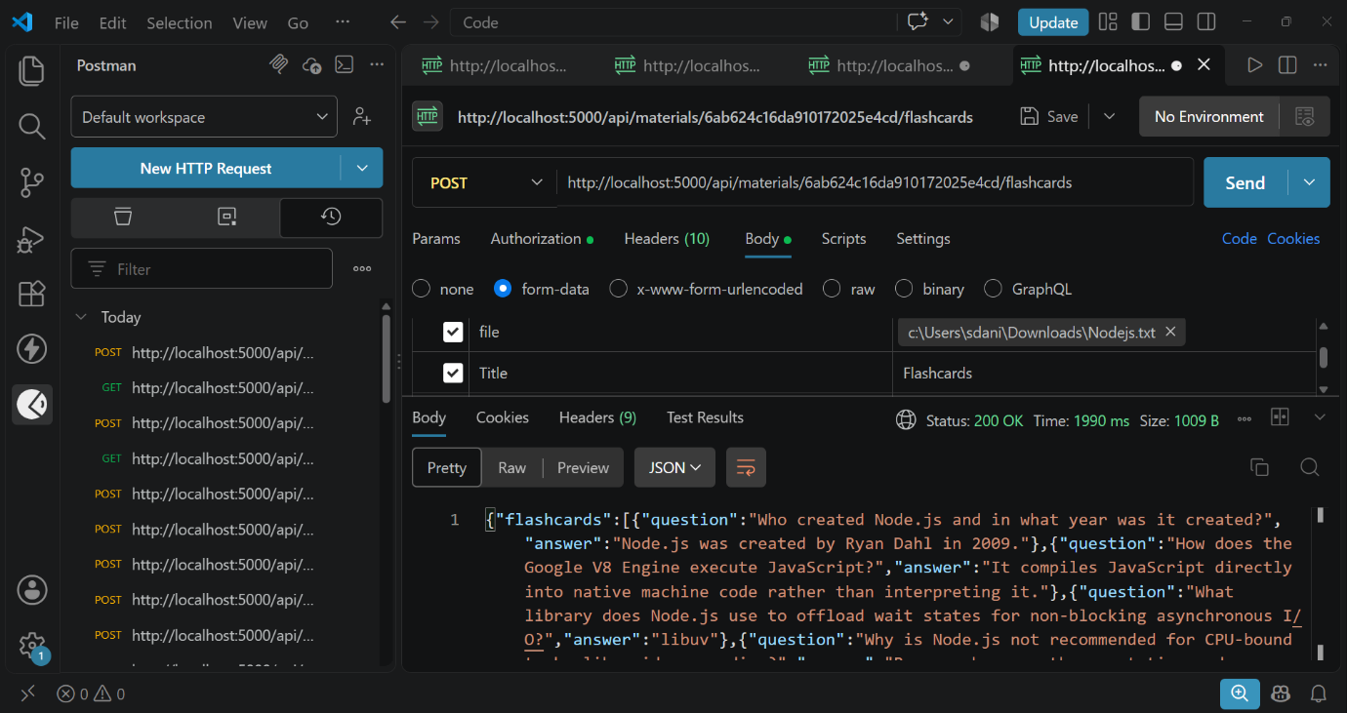

6. Generate AI Quiz
Generates multiple-choice questions from the uploaded study material to help users assess their understanding.
Endpoint:
POST /api/ai/quiz
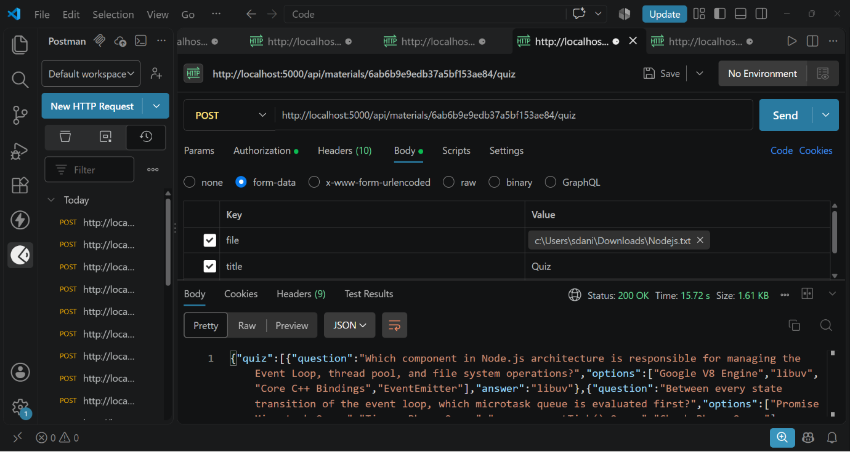

7. Generate AI Study Plan
Creates a personalized study schedule based on the user's learning goals and available study time.
Endpoint:
POST /api/ai/study-plan
